# Mongo DB Installation Guide

Guide for downloading and installation of MongoDB on Windows for the ["MongoDB Course @ SoftUni”](https://softuni.bg/trainings/2811/mongo-db-february-2020).

# Download the MongoDB MSI Installer Package

Download the current version of MongoDB from [here](https://www.mongodb.com/download-center/community). Make sure you **select MSI** as the package you want to download:

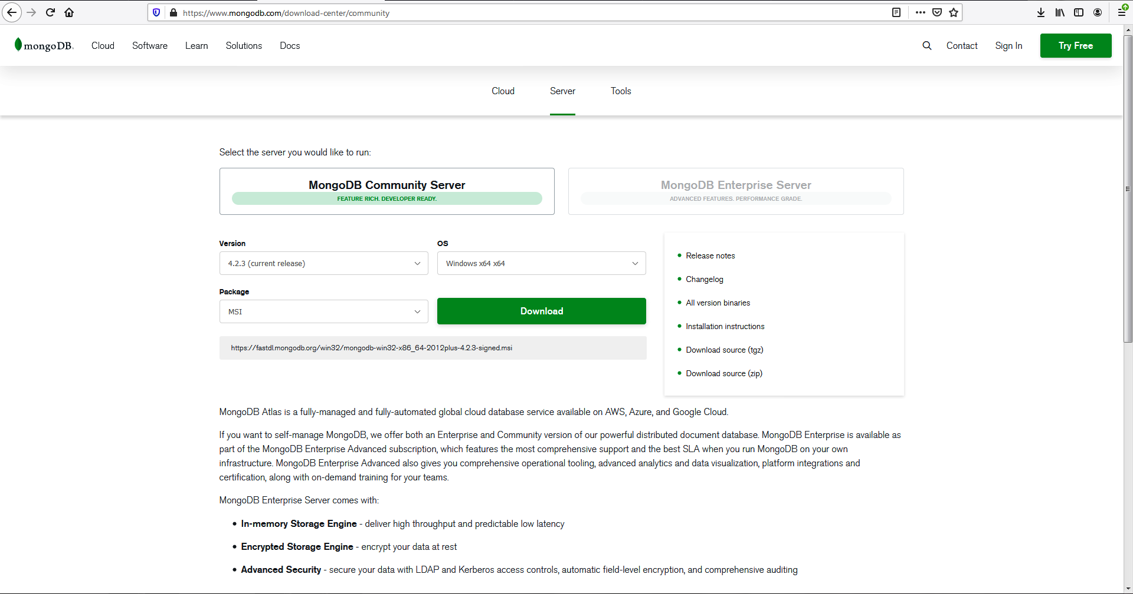

# Installing MongoDB 4.2.3

Navigate to your downloads folder and double click on the .msi package you just downloaded. This will launch the installation wizard.

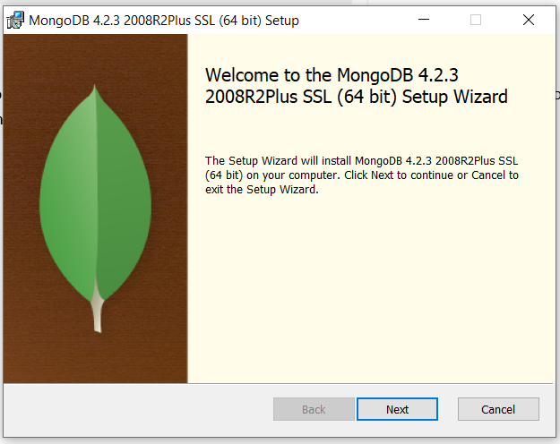

Click **Next**, then accept the licence agreement and click **Next** again. Choose the **Complete** setup type:

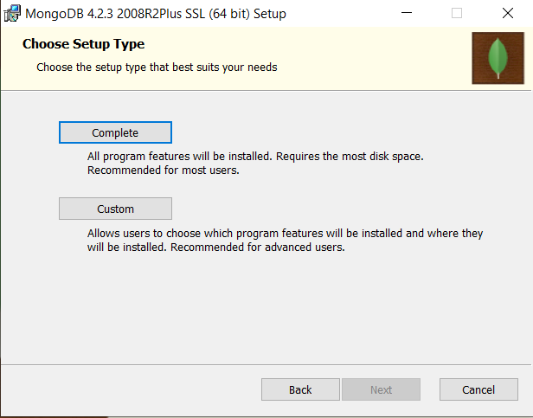

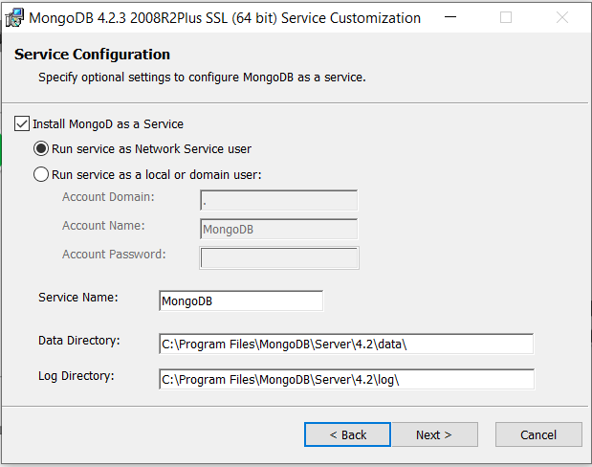

Here we stay with the default option **Install MongoD as a Service** and **Run service as Network Service user**.

Then go through **Install** and **Finish** like this:

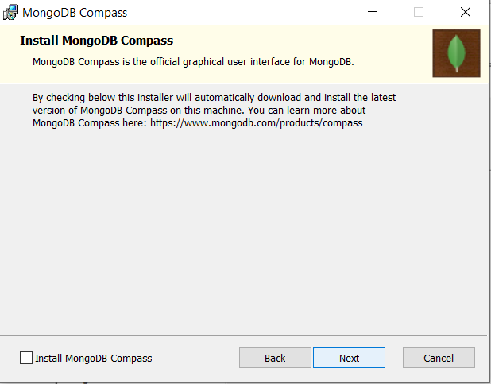 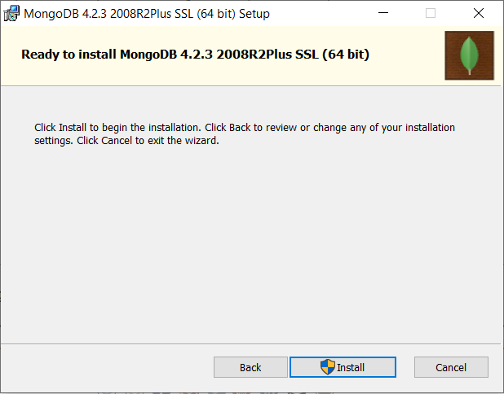

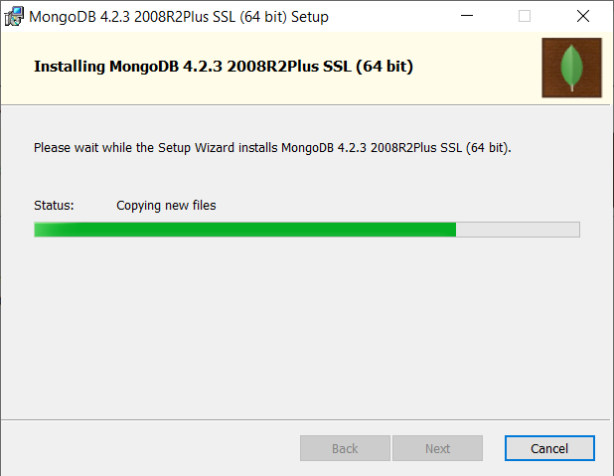 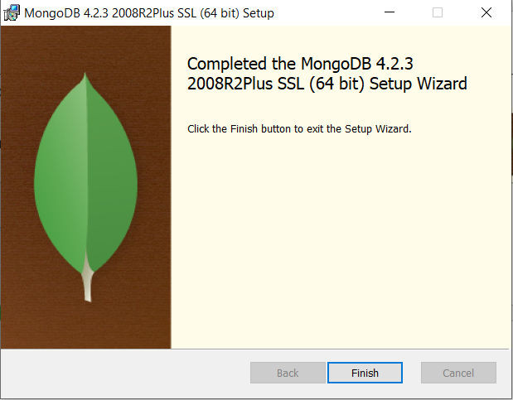

Finishing the installation you need to **restart** your system:

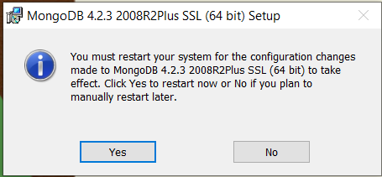

# Setups and test

Navigate to the installed MongoDB **bin** folder 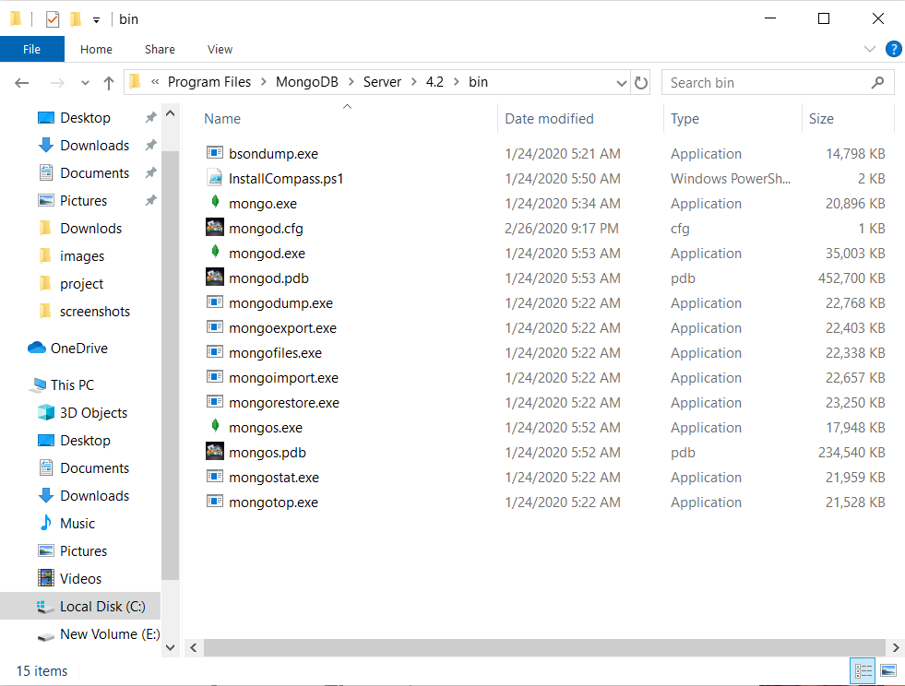

Open the folder in command prompt and run **>mongod** command.

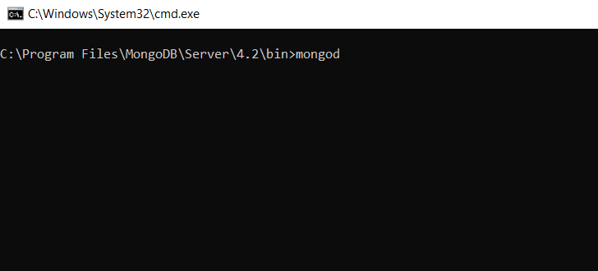

mongod is the primary daemon process for the MongoDB system. It handles data requests, manages data access, and performs background management operations. We just started the mongo diomond:

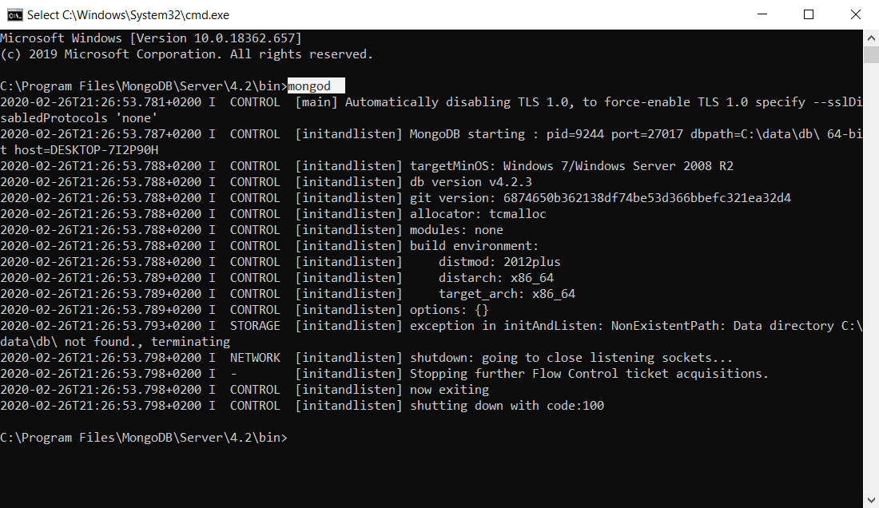

**MongoDB** requires a **data folder** to store its files. The default location for the **MongoDB data directory** is **C:\data\db**. So you need to create **data** folder and **db** folder in it**:**

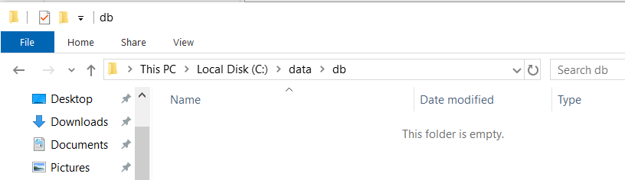

Now open new command prompt, navigate to the bin folder again and run the **>mongo** command

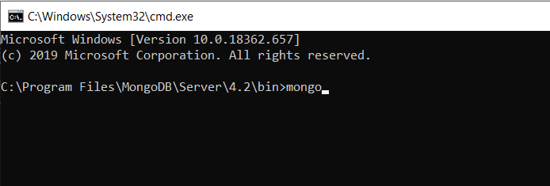

This will run the [**MongoDB shell**](https://docs.mongodb.com/manual/mongo/). You can use the mongo shell to query and update data as well as perform administrative operations. Here we can test and manually create new database, add a collection in it.

To print a list of all databases on the server we use the **>show dbs** command.

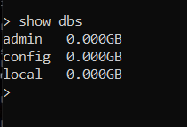

Creat new database by **> use <databaseName>**

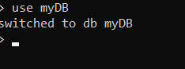

To see the new database with show command we shoud first put same data in it. We can create a new collection with a document using **> db.<collectionName>.insert(document)** . Example:



Now **> show dbs** will show us our new database:

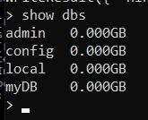

And **> show collections** will show us the new collection:

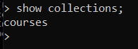

Executing **>**  **db.collection.find()** in the mongo shell automatically iterates the cursor to display up to the first 20 documents if any.

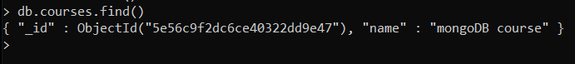

Now you have MongoDB installed, tested and ready to work. More info read on [**The MongoDB 4.2 Manual.**](https://docs.mongodb.com/manual/mongo/)